Time Series Forecasting using ARIMA model

A Brief about the ARIMA Model

ARIMA, short for ‘**Auto Regressive Integrated Moving Average’** is actually a class of models that ‘explains’ a given time series based on its own past values, that is, its own lags and the lagged forecast errors, so that equation can be used to forecast future values. Any ‘non-seasonal’ time series that exhibits patterns and is not a random white noise can be modeled with ARIMA models.

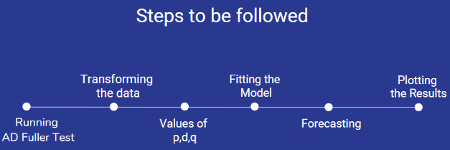

Running Ad Fuller Test

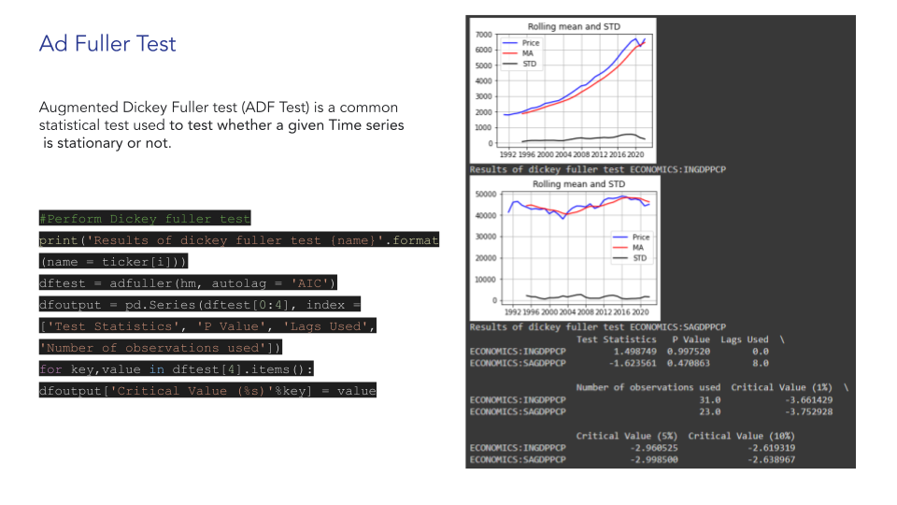

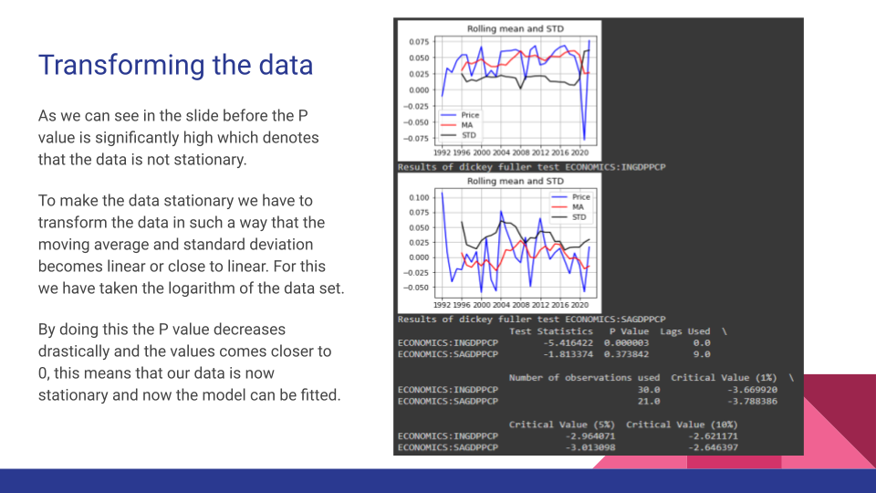

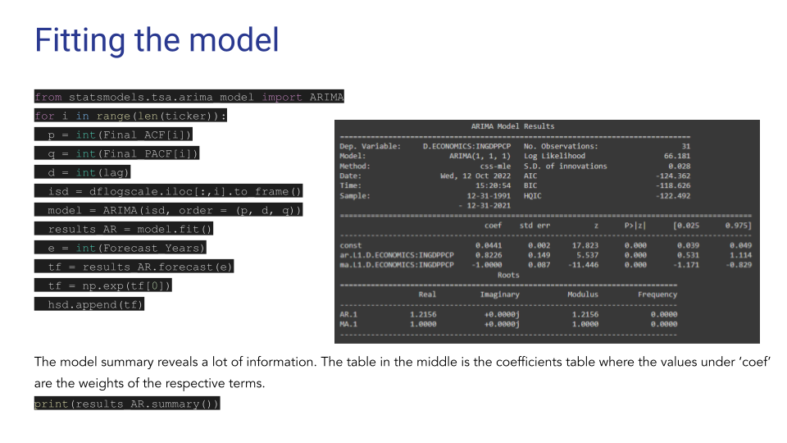

Forecasting and Plotting

